

PARSHVANATH CHARITABLE TRUST'S

1. **P. Shah Institute of Technology**

**Thane, 400615**

**Academic Year: 2022-23**

**Department of Computer Engineering**

# CSL605 SKILL BASED LAB COURSE: CLOUD COMPUTING

**Mini Project Report**

* **Title of Project**  : **JEDI**
* **Year and Semester**  : **T.E. (Sem VI)**
* **Group Members Roll No. & Name** :

1. **Dhruv Mehta**
2. **Anupama Menon**
3. **Itisha Mathane**

**Table of Contents**

|  |  |  |
| --- | --- | --- |
| **Sr**. **No.** | **Topic** | **Page No.** |
| 1. | Abstract | 1 |
| 2. | Introduction | 1 |
| 3. | Problem Statement | 2 |
| 4. | Objective & Scope | 2 |
| 5. | Description (Include the cloud services used in the project, methodologies used and software requirements) | 3 |
| 6. | Implementation details with screen-shots (stepwise) | 4 |
| 7. | Learning Outcome | 8 |

1. **Abstract**

To build a fault tolerant (well what is the harm in calling it one), decentralized micro-blogging platform to express the fundamental human right i.e. Free Speech . Traditional "Social Media" platforms, were never designed to keep their user's opinions at priority. The gate-keepers are generally happy as long as they have a huge growing number of daily active users. They seldom care about what happens to the user's content and usually turn away when matters concerning privacy or goverment interference come to limelight. We on the other hand, kind of are not happy with the way things are happening, so we thought of a way were in we can bring about newer people respecting technologies onto the pre-existing ones.

We just intend to to be a twig and hope others help us build the nest.

1. **Introduction**

The project comprehends the internal workings of IPFS and integrate decentralized software system design patterns into current legacy system architectures. The purpose is to acquire knowledge about fault-tolerant systems and data redundancy techniques, with a particular focus on them. Initially, we plan to develop a functional prototype of the core application and then concentrate on the IPFS component, which is our primary aim. Ultimately, the project aims to provide a platform for users to express themselves freely without the concern of surveillance, profiling, or censorship of their thoughts.

1. **Problem Statement**

[Decentralization,Content Deletion,Content Archival, Content Censhorship]

By todays web standard, that is the web 2.0 , there really existis no decentraliz ation in reality.Everything is governed by a central authority, which then plays the monopoly. Our project aims to tackle this problem through a releatively new technology knows as IPFS.

1. **Objective and Scope**

**Objective**

To provide our users a platform where they can truly express themselves without the underlying fear of being monitered, profiled and we try our level best to prevent our user's thoughts from being censored.

**Scope**

To understand the inner working of IPFS and (design+incorporate) decentralized software system design patterns to existing legacy system architectures. To gain insits on fault taulorent systems and data redundancy techniques specifically. We intend to implement a working model of the core application as soon as possible and then start working on the IPFS part, for that is our main intend.

1. **Description**

**Services Used:**

**IAM users**

An AWS Identity and Access Management (IAM) user is an entity that you create in AWS. The IAM user represents the human user or workload who uses the IAM user to interact with AWS. A user in AWS consists of a name and credentials.

An IAM user with administrator permissions is not the same thing as the AWS account root user.

**VPC**

Amazon Virtual Private Cloud (Amazon VPC) enables you to launch AWS resources into a virtual network that you've defined. This virtual network closely resembles a traditional network that one would operate in his/her own data center, with the benefits of using the scalable infrastructure of AWS.

**EC2**

Amazon Elastic Compute Cloud (Amazon EC2) is a web service that provides secure, resizable compute capacity in the cloud. It is designed to make web-scale cloud computing easier for developers. Amazon EC2's simple web service interface allows you to obtain and configure capacity with minimal friction.

1. **Implementation details with screenshots**

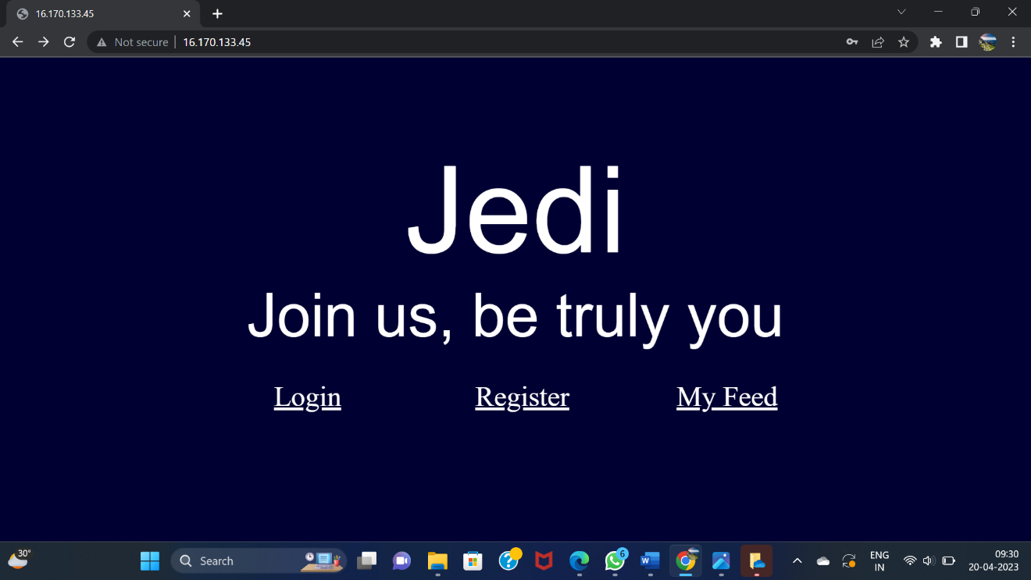

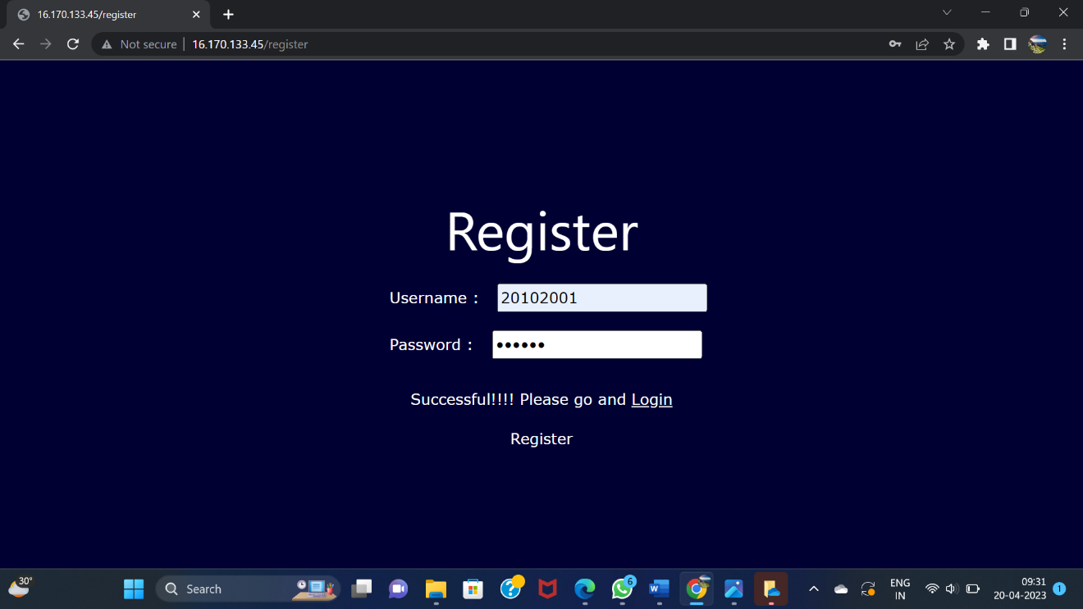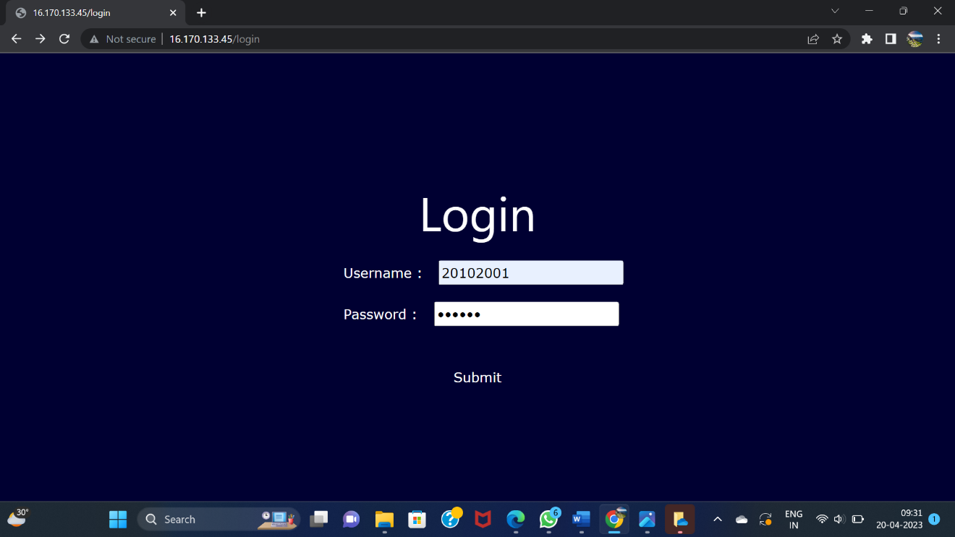

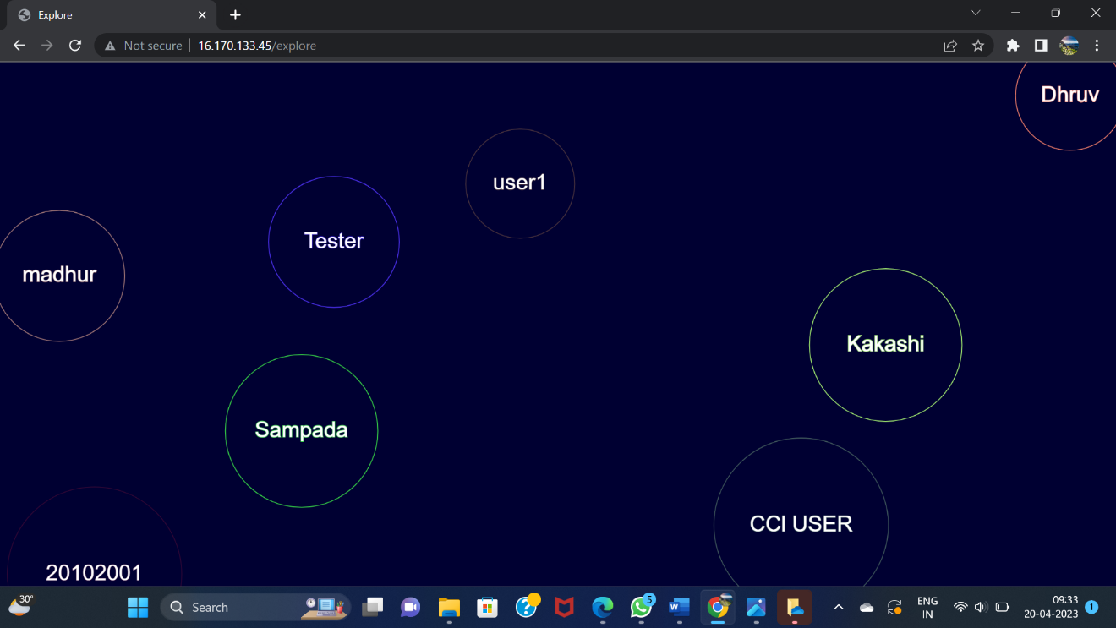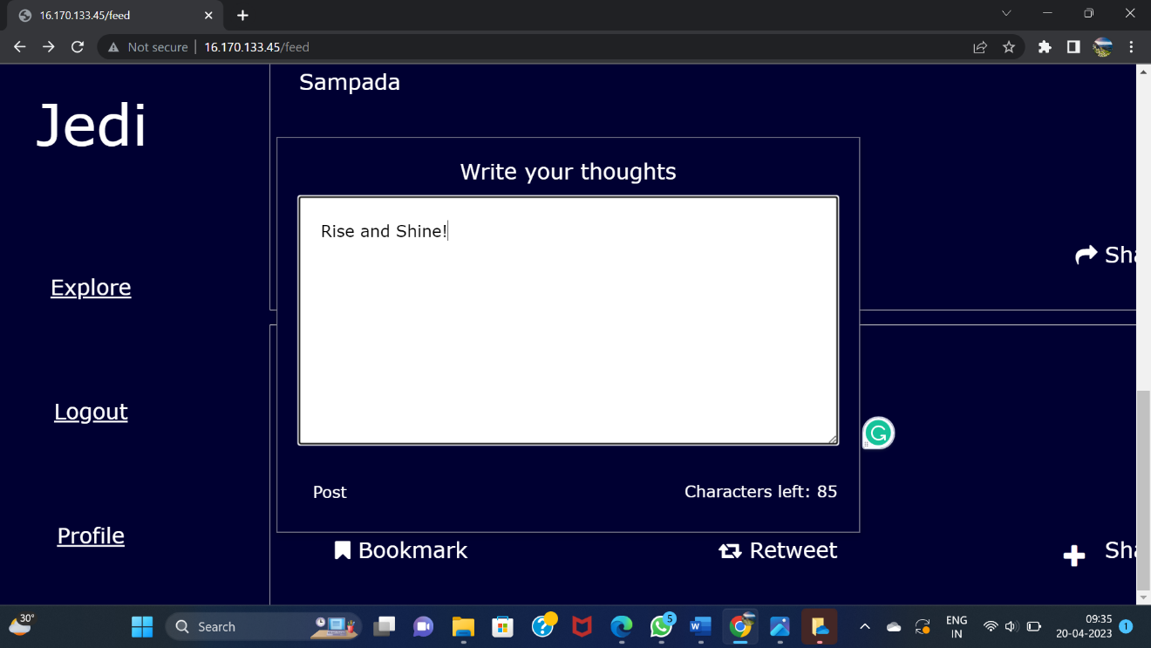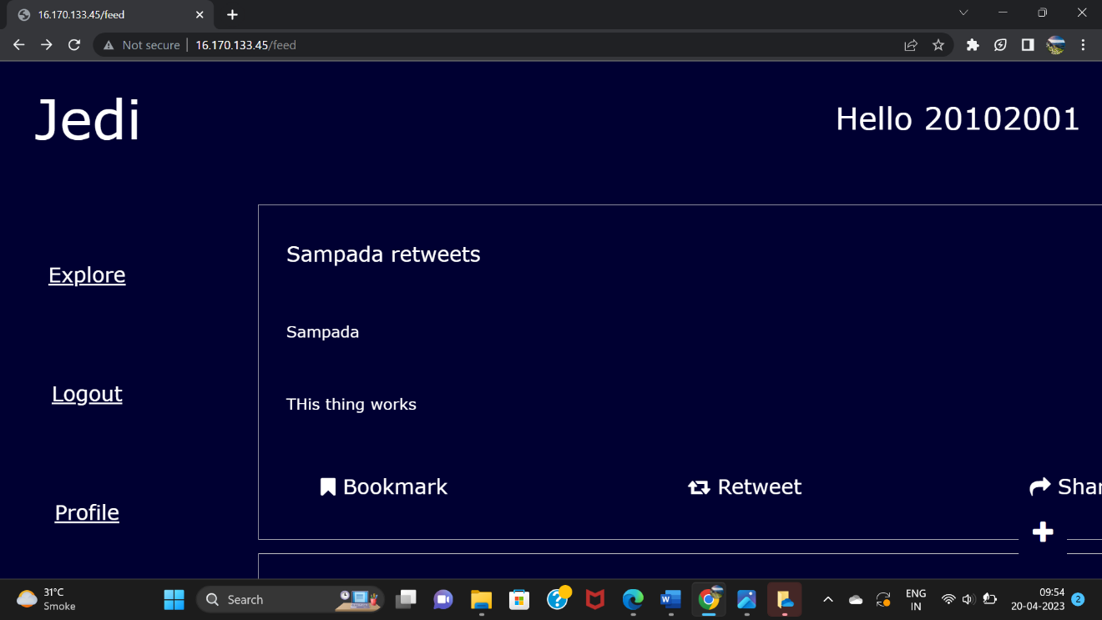

1. **Learning Outcomes**

Through using AWS EC2,VPC and IAM Users in this project we have accomplished various learning outcomes:

1.Cloud computing: The project offers a chance to learn more about cloud computing and the advantages of using cloud storage platforms like AWS EC2. Understanding how to use cloud computing resources to create scalable and secure apps can be improved by this experience.

2.Identity and access management: The use of IAM policies to gain knowledge on how to centrally manage permissions that control which AWS resources users can access and use IAM to control who is authenticated (signed in) and authorized (has permissions) to use resources etc.

3.VPC:The use of VPC allowed us to understand how to launch our resources on a virtual network created,

Overall the project provided us the opportunity to know more about cloud computing, iam policies, vpc etc . Thus helping us develop a safe secure cloud computing application